Instructions for Authors

1. General Information
The format short paper should be A4 with single column, 3.5 cm for upper margin, 2.5 cm for bottom margin and 3.0 cm for lateral margins, without headers or footers.
The main font must be Times, 12 point nominal size, without space before and after each paragraph.
Page numbers must be suppressed.
The short papers must respect the limit of 3 pages defined by the conference.

2. The Title and Authorship
The title must be centered over the whole page, in 16 point boldface font and with 12 points of space before itself.
Author names, affiliations, and e-mail addresses must be suppressed.

3. Sections and Paragraphs
Section titles must be in boldface, 13pt, flush left.
Section numbering is optional.
The first paragraph of each section should not be indented, while the first lines of subsequent paragraphs should be indented by 1.27 cm.

3.1. Subsections
The subsection titles must be in boldface, 12pt, flush left.

4. Figures and Captions
Figure and table captions should be centered if less than one line (Figure 1), otherwise justified and indented by 0.8cm on both margins, as shown in Figure 2.
The caption font must be Helvetica, 10 point, boldface, with 6 points of space before and after each caption.


Figure 1. A typical figure
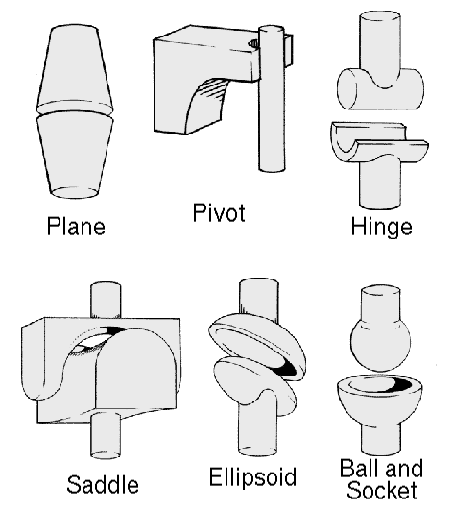
Figure 2. This figure is an example of a figure caption taking more than one line and justified considering margins mentioned in Section 5.

In tables, try to avoid the use of colored or shaded backgrounds, and avoid thick, doubled, or unnecessary framing lines. When reporting empirical data, do not use more decimal digits than warranted by their precision and reproducibility. Table caption must be placed before the table (see Table 1) and the font used must also be Helvetica, 10 point, boldface, with 6 points of space before and after each caption.

Table 1. Variables to be considered on the evaluation of interaction techniques
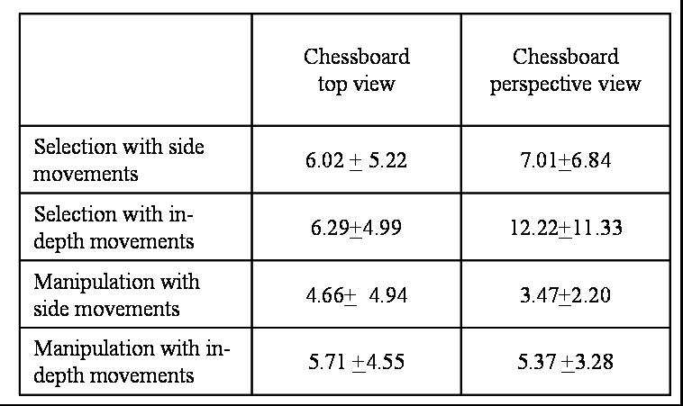

5. References
Bibliographic references must be unambiguous and uniform. We recommend giving the author names references in brackets, e.g. [Knuth 1984], [Boulic and Renault 1991]; or dates in parentheses, e.g. Knuth (1984), Smith and Jones (1999).
The references must be listed using 12 point font size, without space before and after each paragraph.
The first line of each reference should not be indented, while the subsequent should be indented by 0.5 cm.

References
Boulic, R. and Renault, O. (1991) “3D Hierarchies for Animation”, In: New Trends in Animation and Visualization, Edited by Nadia Magnenat-Thalmann and Daniel Thalmann, John Wiley & Sons ltd., England.
Dyer, S., Martin, J. and Zulauf, J. (1995) “Motion Capture White Paper”, http://reality.sgi.com/employees/jam_sb/mocap/MoCapWP_v2.0.html, December.
Holton, M. and Alexander, S. (1995) “Soft Cellular Modeling: A Technique for the Simulation of Non-rigid Materials”, Computer Graphics: Developments in Virtual Environments, R. A. Earnshaw and J. A. Vince, England, Academic Press Ltd., p. 449-460.
Knuth, D. E. (1984), The TeXbook, Addison Wesley, 15th edition.
Smith, A. and Jones, B. (1999). On the complexity of computing. In Advances in Computer Science, pages 555–566. Publishing Press.

